Tomboulian@aol.com
TomboulianN@cravencc.edu
ContactNolanT@gmail.com
252 – 675 – 0176
This course uses materials created by NORTHSTAR. https://www.digitalliteracyassessment.org/
An account has been created for you using your Craven Community College Email.
There are 14 topics, but this class will focus on six.
1) Basic Computer Skills (8 lessons)
2) Basic Internet Skills (9 lessons)
3) Basic Email Skills (7 lessons)
4) Information Literacy (7 lessons)
5) Digital Footprint (5 lessons)
6) Windows 10 (7 Lessons)

The course will consist of Instruction, practice, and tests.
When you are ready, you can take a test for Certification for each topic to earn ‘Certification Badges’.
In addition to the materials provided as part of the course, NorthStar has created a link to external resources: https://www.digitalliteracyassessment.org/external-resources
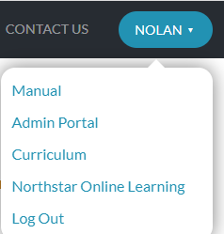
You may work on the additional topics on your own.
After you LOGIN, Click on the ‘Drop Down’ arrow by your name and select: Northstar ONLINE Learning

You will see the Dashboard and Menu Topics.

